3. Save

A. System Sequence Diagram

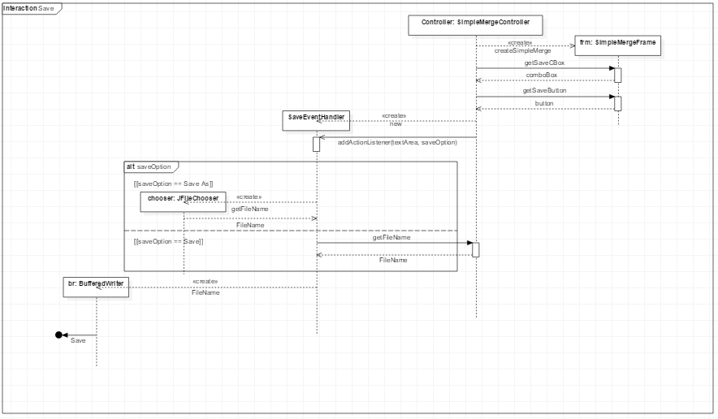

Description

Premise) Main Class’s Function creates Controller Instance.

1. The user selects saveOption and press save button.
2. Sets the FileName, Directory.
3. If saveOption is “Save”, get the FileName, Directory from the SimpleMergeController.
4. If saveOption is “Save As”, get the FileName, Directory from chooser.
5. Save it with the specified FileName and Directory.

B. Implementation

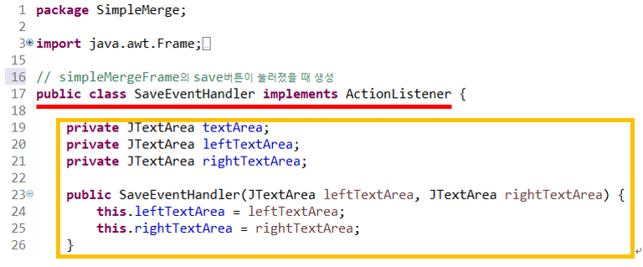

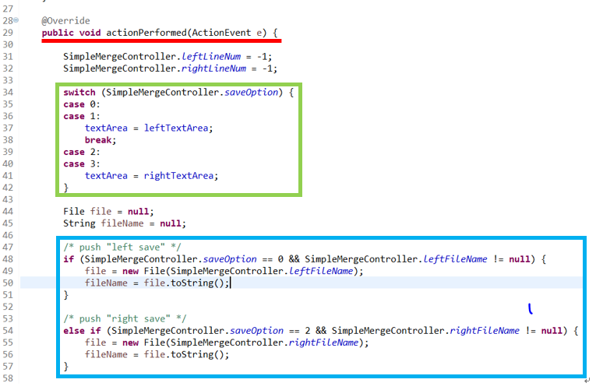

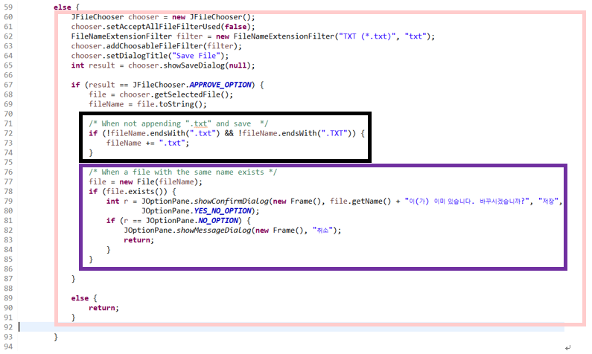

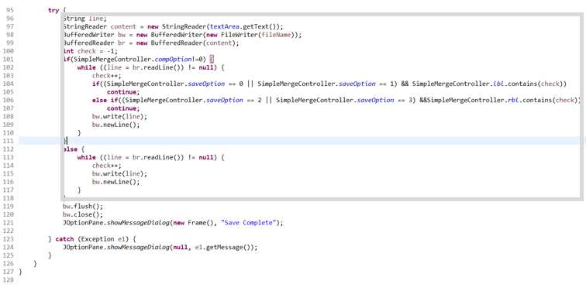

Description:

1. Dependency of SaveEventHandler



SaveEventHandler implements the ActionListener interface.

1. textArea’s Role as Controller

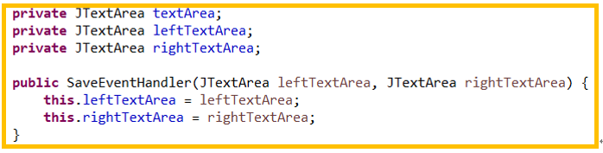

SaveEventHandler acts as a sub-controller for Save case for the Controller instance. Therefore SaveEventHandler class receives access to textArea.

1. Save Option ( left save, left save as, right save, right save as )

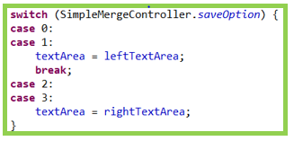

We read the variable of SimpleMergeController to distinguish between left storage and right storage. And put the appropriate textArea in the class variable textArea.

1. Situation ( push “save” button after “load” button)

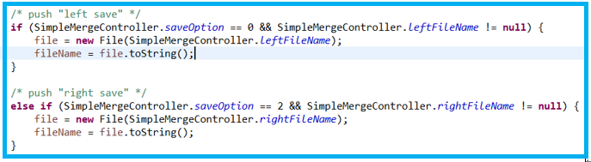

Take the file location of the load from SimpleMergeController and save the contents of textArea.

1. Exceptional Situation Handling ( Not appending “.txt” and Save )

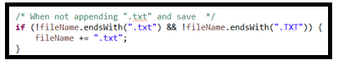

If you append “.txt” and press save button, save as is. But If you don’t append “.txt” and press save button, append “.TXT” at the end and save.

1. Exceptional Situation Handling ( Same name file exists )

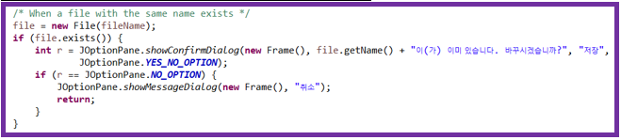

When saving, if there is a file with the same name, a new Frame() is opened to select whether to overwrite or cancel.

1. Functional Logic Flow

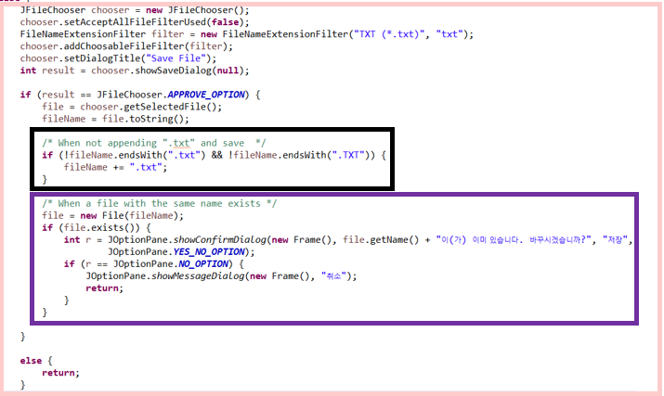

A window titled “Save File” will be displayed.

Specify the location to save.

Set the file name to be saved.

Press button to save. Only “.txt” files can be formatted.

1. Situation ( When you press the “save” button with a fake space created after pressing the “compare” button )

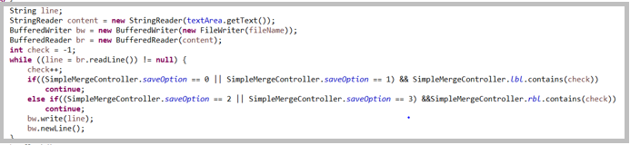

In this situation, we ignore fake space and save it in a file.

III. Program Testing

IV. Results

3. Save

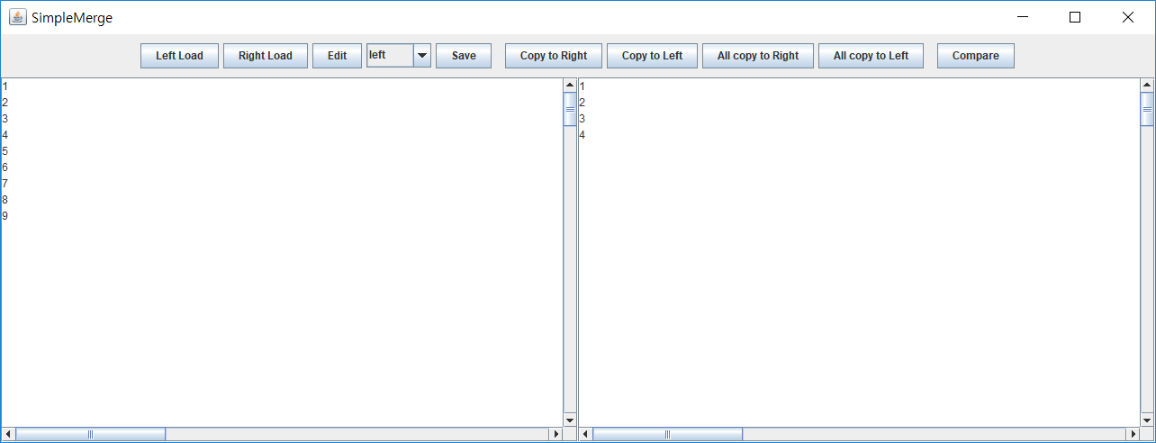

1. Press Save Btn, Save Option = left, right

- When you press the Save button, a window will pop up informing you that the save is complete.

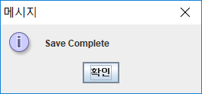 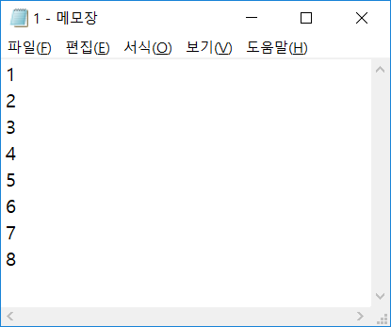

1. Press Save Btn, Save Option = left as, right as

- When you press the Save button, JFileChooser window will pop up.

- Select the location you want to save and write the file name.

- Click save.

- Window will pop up informing you that the save is complete.

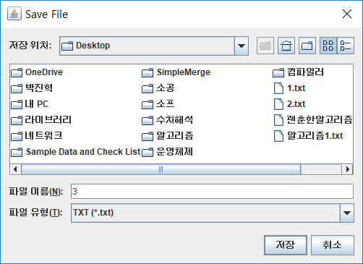 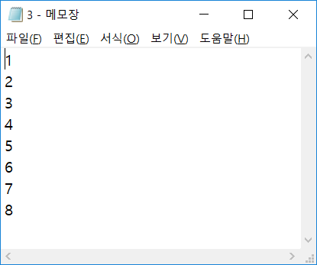

3) Exceptional Situation Handling ( Same name file exists )

- If a file with the same name exists in the location you want to save, a window will pop up asking you to overwrite or cancel.

